Уровень Elementary

Welcome to our Speak Out Studio!
Today we are going to talk about the Queen. Read the text and answer the questions:
Great Britain has got a Queen. Her name is Elizabeth. Her surname is Windsor. The queen is very old. She is 90.
The Queen has got a big family. She has got three sons and a daughter. Queen Elizabeth wants her grandson William to be King soon.

The queen is very active. She likes football. She likes to watch football matches. She can ride a horse and drive a car. She can speak French well. She likes nice hats and dresses.

The Queen loves her country and her people love her.

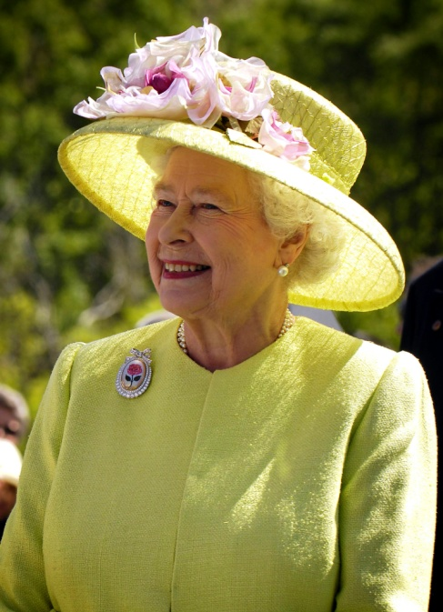
- Has Great Britain got a queen or a King?
- How old is she?
- Has she got a big family?
- What does she do?
- What is she like?

Далее на занятии появляется Королева (ее роль исполняет педагог «Английского клуба»), начинается контролируемое общение на языке: дети задают вопросы, королева отвечает и наоборот. Также дети декламируют стихи, поют песенки на английском, чтобы показать Королеве, чему они уже научились.

